LifeHub

**Assignment 3 – Group 2**

**A Job Application Website**

Jiamin Luo (8986565)

Nhi Ha Thao Nguyen (9022701)

Gargi Dipen Dave (8966699)

Kurians Mathew (8941633)

Computer Applications Development, Conestoga College

INFO8003: Systems Concepts, Analysis and Design

Randall Kozak

10 December 2024

**Introduction** 3

**Brainstorming** 4

**Research** 4

**Description** 8

**Technical Requirements** 11

**Personas** 11

**Use Case** 12

**1.** **Use case diagram** 12

**2.** **Use case description** 13

**Activity Diagram** 19

**Entity** 19

**Content Plans** 23

**Class Diagram** 24

**Prototype** 25

**Agile Plan** 31

**Conclusion** 35

# **Introduction**

In today's fast-paced world, people are always searching for effective, efficient solutions to meet their everyday demands. Users frequently find themselves juggling various apps or platforms, whether they are looking for a trustworthy apartment sublet, a carpool for their commute, or a good deal on used goods. Although there are numerous apps that address these distinct demands, very few provide a single, cohesive solution that combines all these features into a smooth user experience. Here's where our new app can help.

Our goal is to develop a comprehensive platform that integrates apartment subletting, carpooling, buying and selling used goods, and more into a single app. This app's comprehensive experience will enable users to access a variety of services with a few clicks, eliminating the need to download separate apps for each purpose. The app's primary goal is to encourage community involvement by making sure that users can rely on and trust one another. The app's integrated user profiles, reviews, and ratings foster confidence and assist users in making wise choices. Additionally, it offers smooth in-app payment choices with an extra degree of oversight, guaranteeing safe and dependable transactions amongst users. Whether you're a renter, landlord, commuter, or a deal hunter, our app offers the resources you need to interact with people in a reliable and user-friendly manner.

# **Using a collaborative tool**

Repository Link:

# **Brainstorming**

Create a unified platform where users can share and discover various types of information such as carpool services, great deals, second-hand items, and apartment sublets and so on. Using this app, commuters can look for carpooling options, individuals want to buy or sell second-hand items, renters or landlords look to sublet or find tenants. In current market, while there are apps covering parts of these functions, few integrate all these functionalities seamlessly. The app focuses on community engagement, usability, and trust. So, in order to combine these features into one app, help the users saving time without downloading related apps to find a carpool or sublet, provide in-app payment options by supervision, it could fill a gap in the current market.

# **Research**

At first, after researching the field of application, there are some existing apps with similar features. Like Craigslist, Facebook Marketplace, BlaBlaCar, Nextdoor.

1. Craigslist: [https://www.craigslist.org/about/sites](https://www.craigslist.org/about/sites%20)

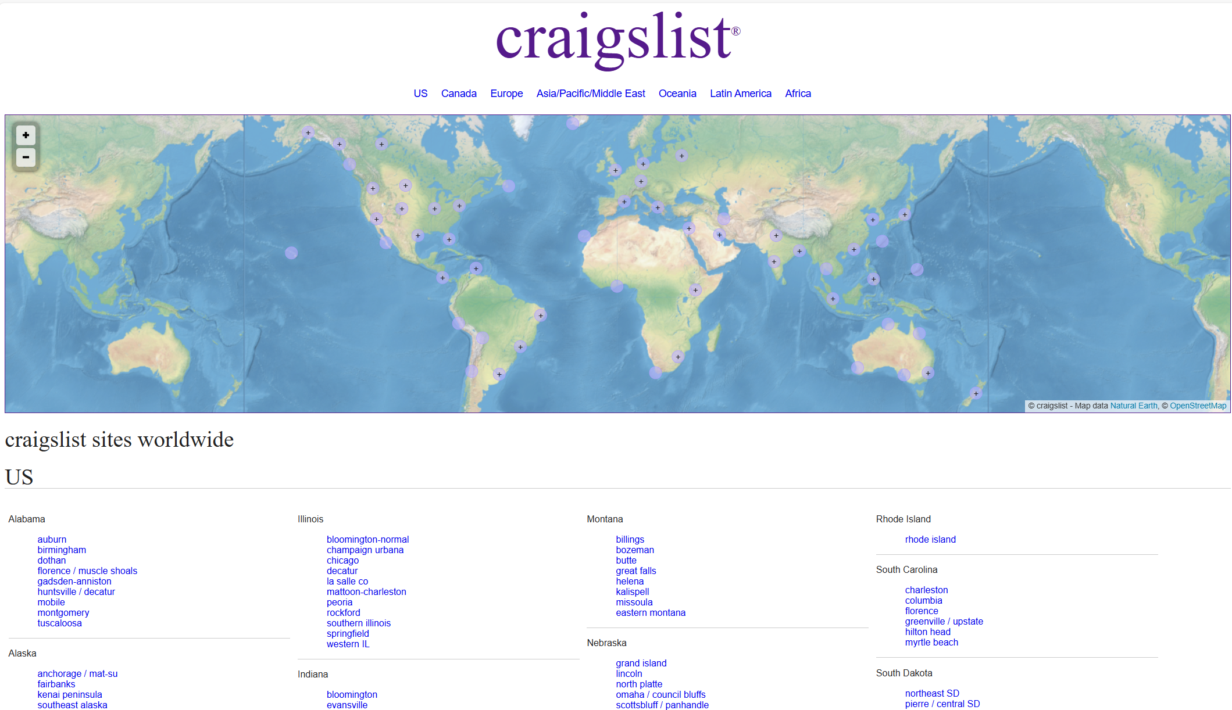

1. Facebook Marketplace[： https://www.facebook.com/marketplace/](：%20https:/www.facebook.com/marketplace/)

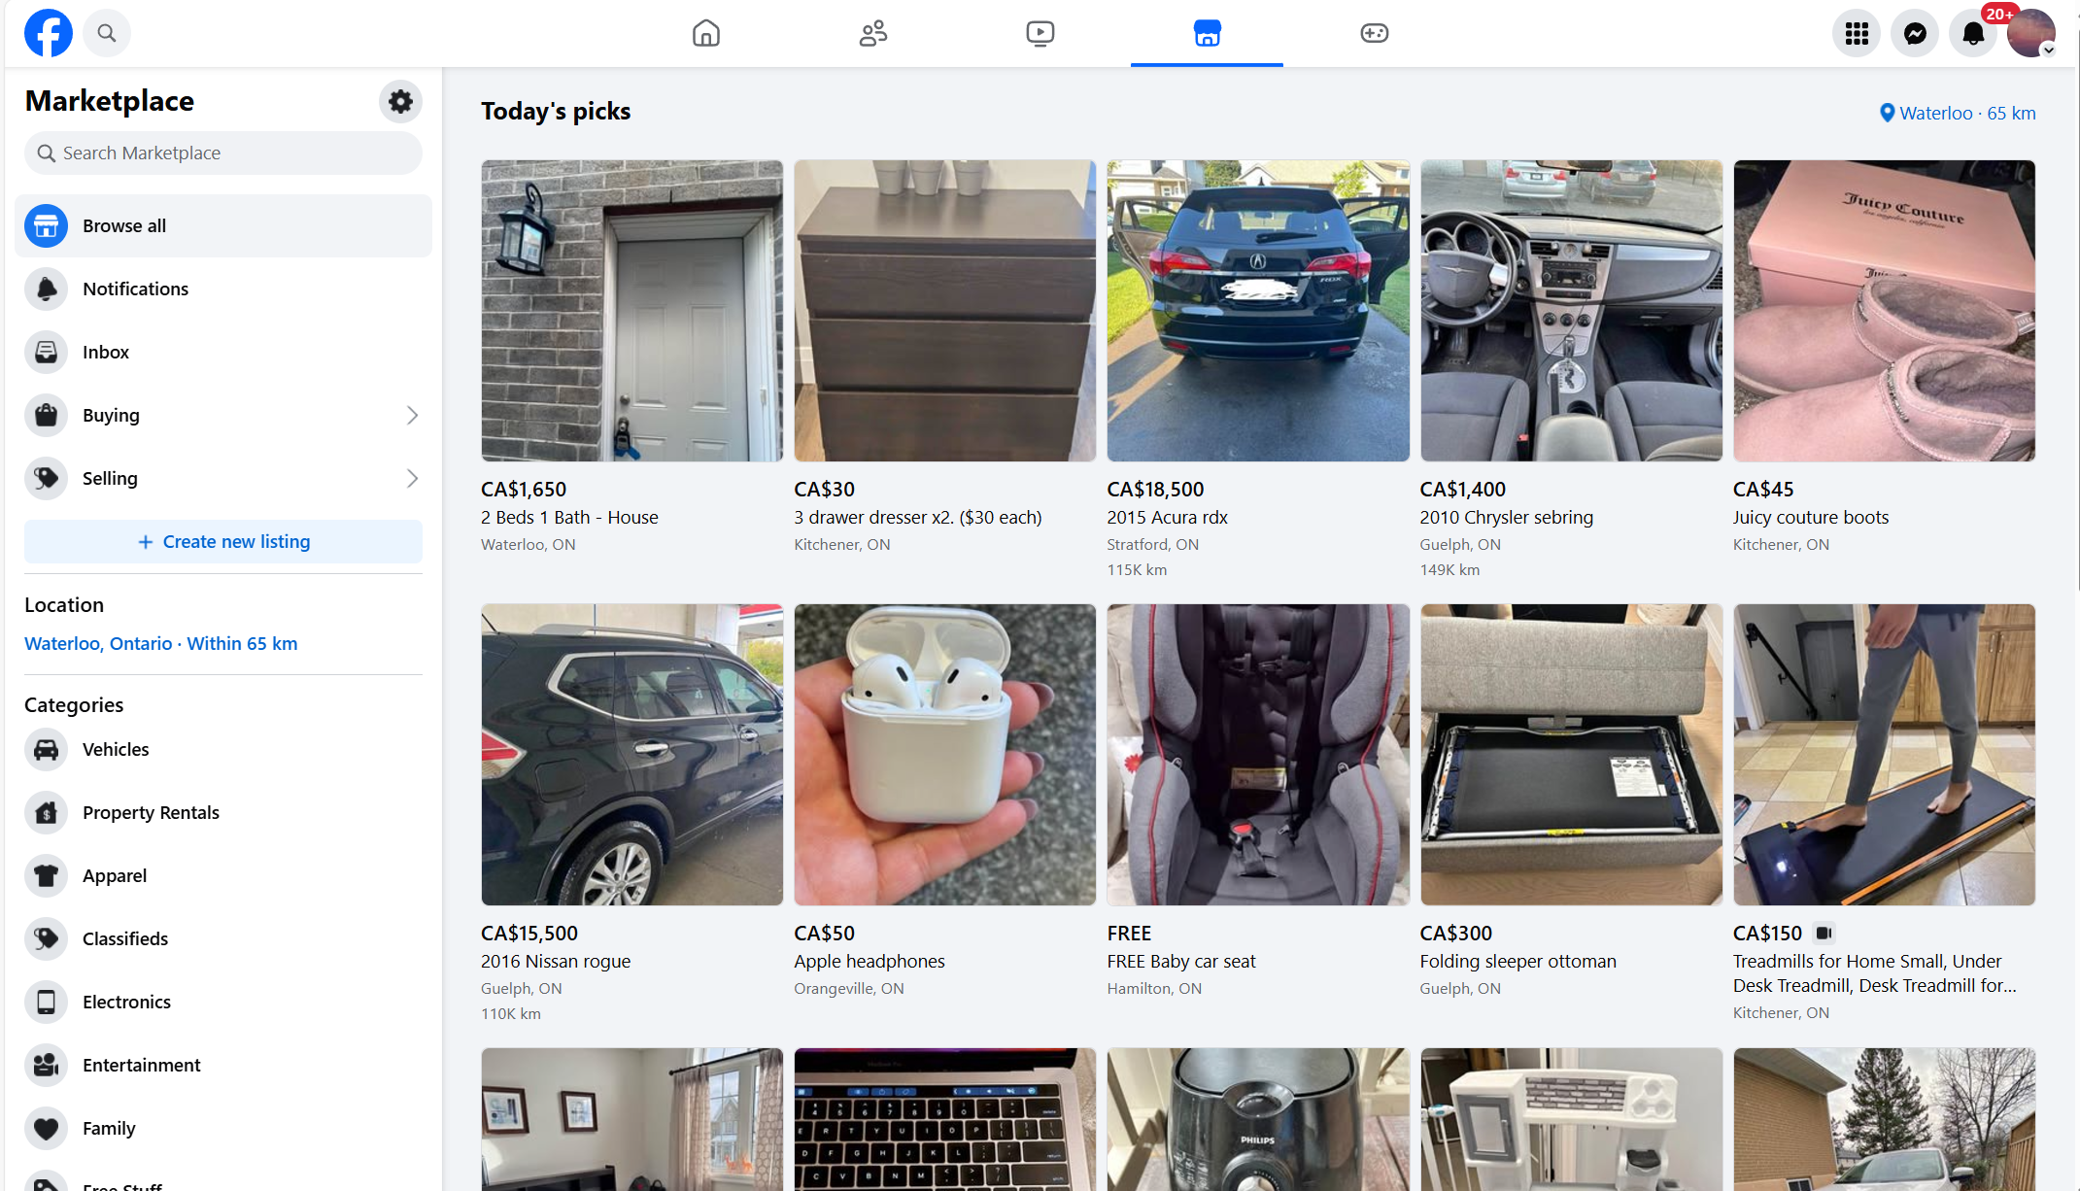

1. BlaBlaCar: <https://www.blablacar.co.uk/>

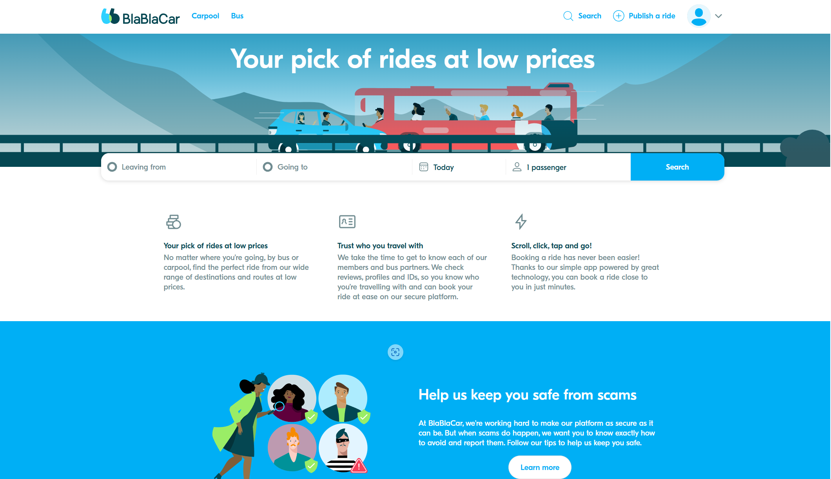

1. Nextdoor: <https://nextdoor.com/>

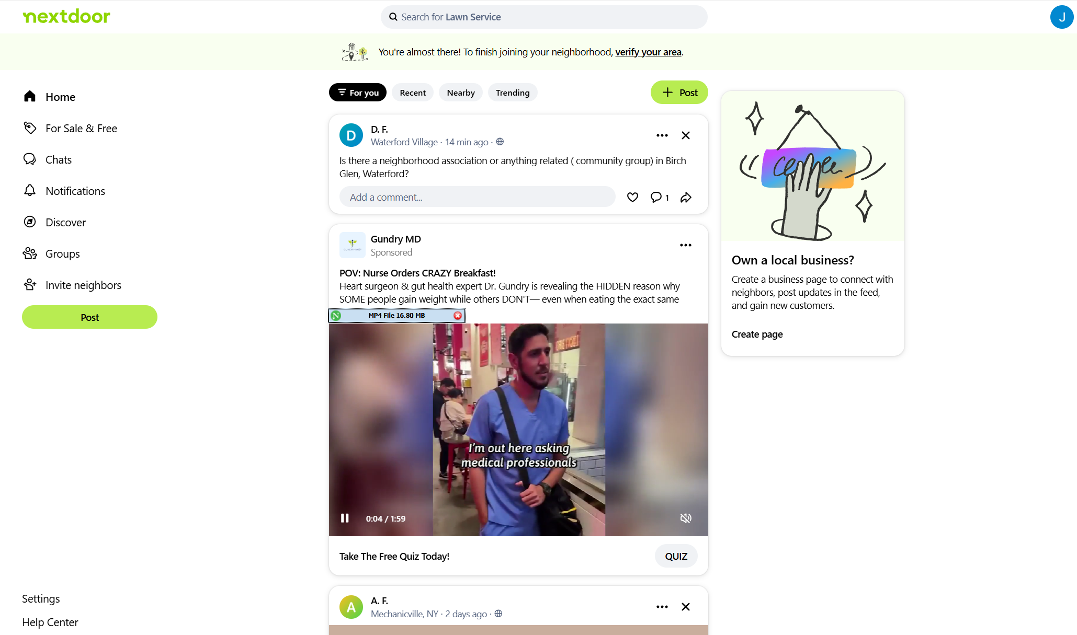

As for people use now to accomplish the same goals, these are the points:

* General Platforms: Facebook, WhatsApp groups, Craigslist.
* Specialized Apps: The apps listed above, though they are fragmented across use cases.

Challenges with Current Solutions:

* Lack of centralization.
* Limited trust mechanisms (e.g., Craigslist).
* Few tools for community-building or hyperlocal discovery.

Therefore, we dedicate ourselves to developing a centralized app with the below features:

1. **Centralized Platform:** Integrate carpooling, item sales, deals, and sublets into one app.
2. **Hyperlocal Focus:** Location-based features for better personalization.
3. **User Trust & Safety:** Verified accounts, user reviews, and content moderation.
4. **Categories:** Allow users to filter and browse through specific categories like carpooling, deals, etc.
5. **Real-time Communication:** In-app messaging and notifications for timely updates.
6. **Payment Options:** Secure payment integration for transactions.
7. **Map View:** Visualize listings and services geographically.
8. **Community Engagement:** Forums or groups for discussions and sharing.

Compared with the other apps in current market, the differences are below:

1. **All-in-One Platform:**
   * Facebook Marketplace no dedicated focus on specific community-driven needs like carpooling.

* Our difference: Combines carpooling, second-hand sales, deals, and rentals, eliminating the need for multiple apps.

1. **Trust & Moderation:**
   * Facebook Marketplace has minimal moderation, lacks dedicated categories like carpooling or deals.
   * Our difference: A robust verification system for users and AI-assisted content moderation.
2. **Tailored to Local Communities:**
   * BlaBlaCar focuses solely on carpooling, without localized services or other community features.
   * Our difference: our app emphasises on hyperlocal interactions, making it easier to connect with nearby users.
3. **Dynamic Posting System:**
   * Craigslist is with outdated design and limited focus on real-time or social interaction.

* Our difference: our app can customize templates for various use cases and focus on community.

Developing this app makes sense for several key reasons:

1. **Market Gap:** No app currently integrates all these functionalities into a cohesive, user-friendly platform.
2. **Hyperlocal Demand:** A growing interest in local, community-focused apps.
3. **Convenience Factor:** Reduces the hassle of juggling multiple platforms.
4. **Scalability:** The app can grow to include other services like job postings, lost & found, or community events.
5. **Revenue Potential:** Freemium model, ads, and transaction fees offer multiple monetization opportunities.

# **Description**

**Refined Description:**

Our app serves as an all-in-one platform, simplifying the process of finding and sharing services such as carpooling, second-hand items, deals, and apartment sublets within local communities. By integrating these features into one seamless interface, the app provides a convenient and efficient solution for users, eliminating the need for multiple specialized apps. The app prioritizes trust, safety, and community engagement, with features like verified user accounts, AI-assisted content moderation, and a robust review system. It offers users the ability to search, communicate, and make secure payments for transactions all within the same platfor. Through location-based services, users can find hyperlocal opportunities, helping them connect with others nearby and fostering a sense of community.

**Business and Social Purposes:**

* **Business Purpose:** To provide a centralized platform where users can access multiple community-driven services. This reduces the friction of using separate apps for different needs and opens up opportunities for revenue generation through freemium models, ads, and transaction fees. The app's design also allows for scalability, enabling the addition of new services and features over time.
* **Social Purpose:** To build a more connected and trust-driven community, where people can easily share services and resources. By fostering safe, localized interactions and supporting the exchange of goods and services within communities, the app contributes to social cohesion and reduces reliance on larger, impersonal platforms.

**Desirable Features (Preliminary List):**

1. **Centralized Platform** for carpooling, second-hand items, deals, and sublets.
2. **Hyperlocal Focus** with location-based filtering and personalized recommendations.
3. **Trust & Safety** through user verification, ratings, and AI-assisted content moderation.
4. **Real-Time Communication** using in-app messaging and notifications.
5. **Secure Payment Integration** with transaction supervision.
6. **Map View** to visualize listings geographically.
7. **Category-Specific Filters** to browse relevant content (e.g., carpooling, sublets, deals).
8. **Community Engagement Features** like forums, group discussions, and local event sharing.
9. **Dynamic Posting Templates** for easy listings creation in various categories.

**Possible Revenue Streams:**

1. **Freemium Model:** Offering premium features (e.g., advanced filtering, priority listings) for a subscription fee.
2. **Transaction Fees:** Taking a small commission on payments processed through the app for carpooling, item sales, or rentals.
3. **In-App Advertising:** Displaying relevant ads based on users' activities and location.
4. **Feature Upgrades for Sellers:** Charging sellers for additional exposure, such as highlighted listings or featured spots in specific categories.

**Future Goals:**

1. **Expansion of Services:** Introduce new features like job postings, lost & found services, and community event listings to further centralize local interactions.
2. **Advanced Search & Matching:** Improve algorithms for better matching of users based on needs, preferences, and location, including AI-powered suggestions.
3. **Social Integration:** Allow users to connect with others through social media or invite friends, boosting the app's network effect.
4. **Sustainability Focus:** Promote eco-friendly options, such as carpooling or sharing items, aligning with global sustainability goals.
5. **International Expansion:** Adapt the platform to serve international markets, tailoring services to local needs and regulations.

**Relation to the Theme:**

The app addresses the growing demand for centralized, community-focused platforms in today's fragmented digital ecosystem. By providing hyperlocal, user-driven solutions for a variety of everyday needs, it fills a market gap, offering a unique blend of social, business, and functional purposes.

# **Technical Requirements**

# **Personas**

Persona #1

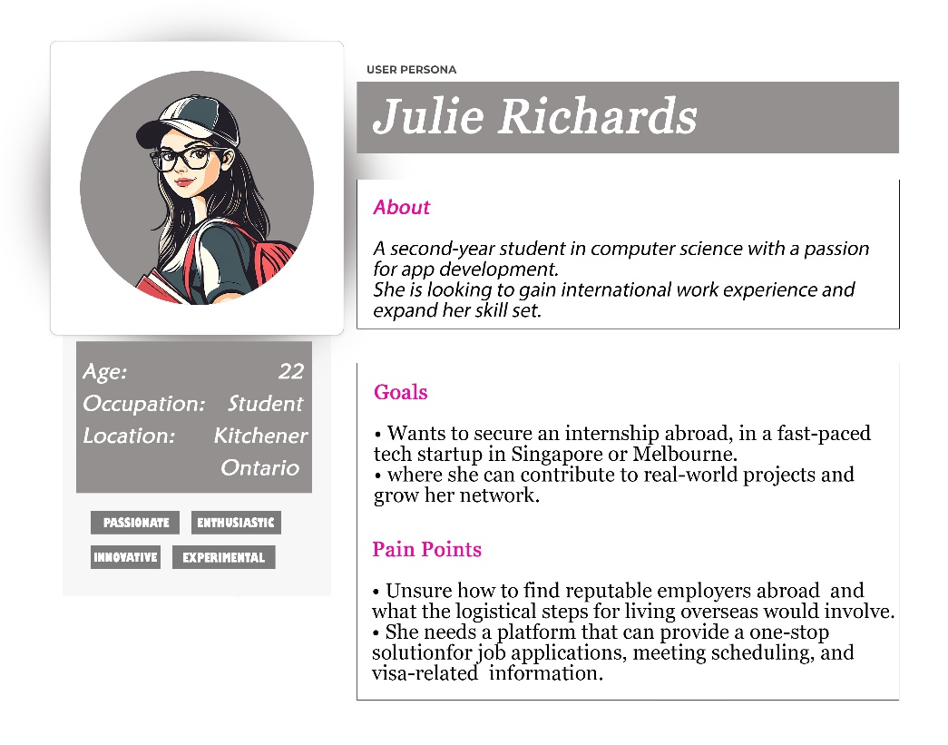

Persona #2

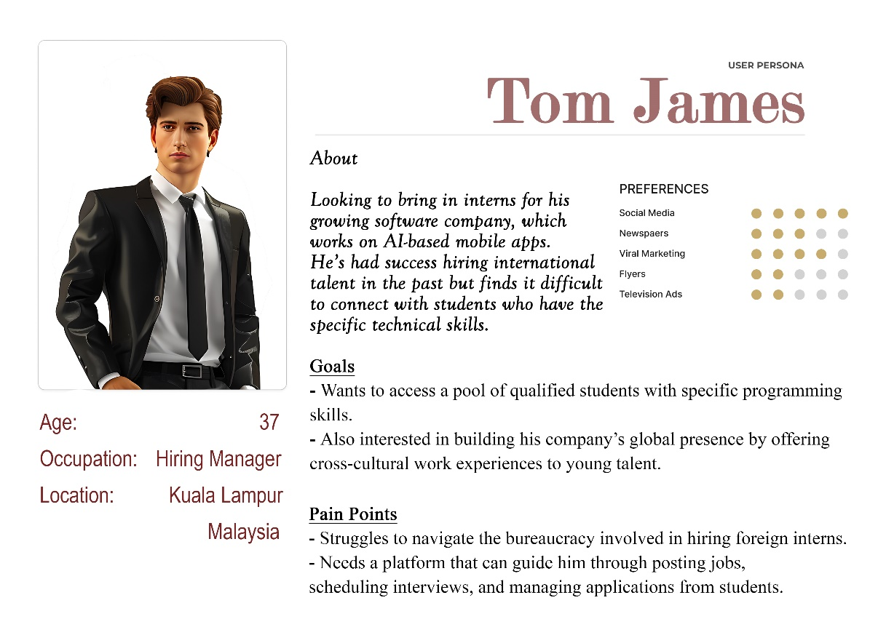

Persona #3

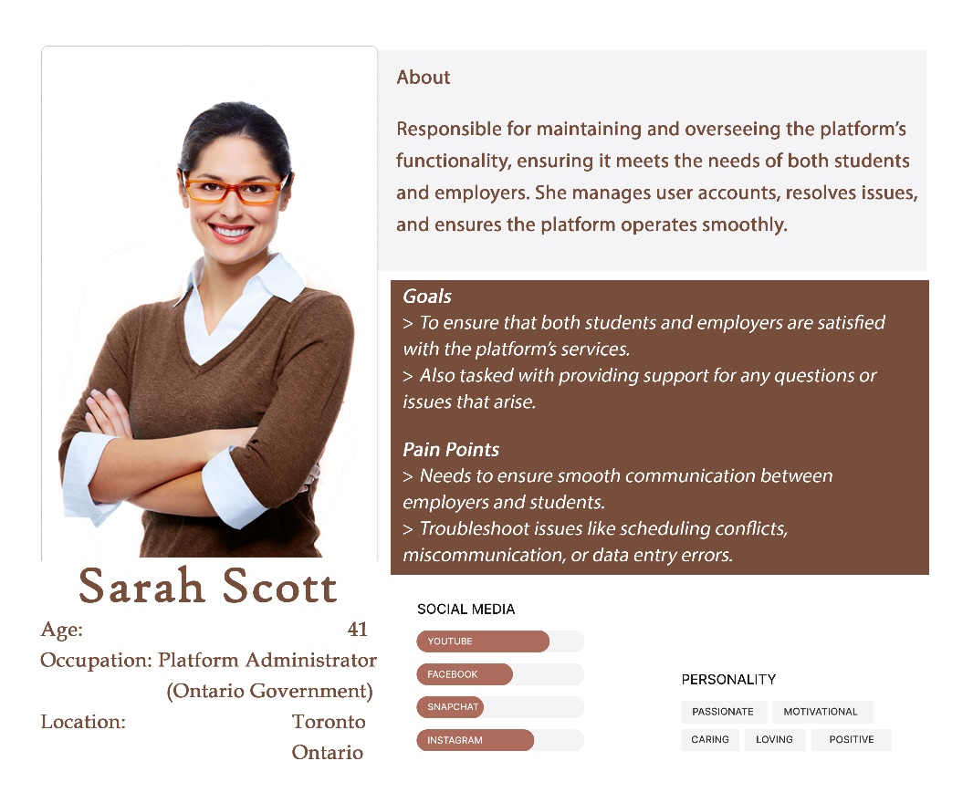

# **Use Case**

### **Use case diagram**

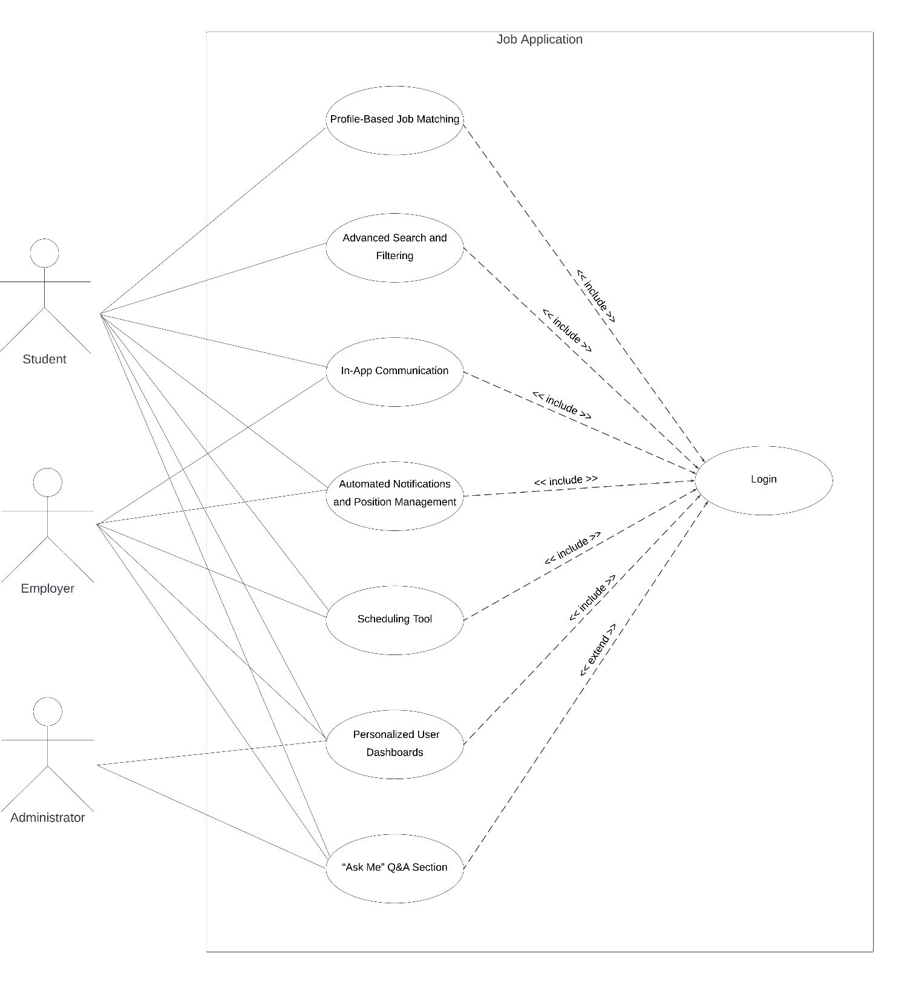

### **Use case description**

|  |  |  |
| --- | --- | --- |
| UC Name | **Personalized User Dashboards** | |
| Brief description | Tailored dashboards for Students, Employers, and Administrators, allowing each user group to see relevant information and tools | |
| Actors | User | |
| Normal Flow of Events | User | System |
|  | 1. The user selects role | 1. Display customized dashboard according to the role |
|  | 1. The user changes dashboard as like. | 1. Save the change and display the new dashboard. |

|  |  |  |
| --- | --- | --- |
| UC Name | **Profile-Based Job Matching** | |
| Brief description | Profiles showcasing students’ skills are matched with relevant jobs, encouraging quick and effective applications. | |
| Actors | User | |
| Normal Flow of Events | User | System |
|  | 1. The user creates own profile and input personal information | 1. Save related information |
|  | 1. The user searches job | 1. Recommend some jobs based on the profile. |

|  |  |  |
| --- | --- | --- |
| UC Name | **Advanced Search and Filtering** | |
| Brief description | Users can filter jobs by location, duration, and required skills to find the most relevant opportunities. | |
| Actors | User | |
| Normal Flow of Events | User | System |
|  |  | 1. Display filter icon |
|  | 1. The user click filter and choose the conditions | 1. Search and display the result according to the conditions. |
|  | 1. The user updates the filter conditions | 1. Search and display the new results |

|  |  |  |
| --- | --- | --- |
| UC Name | **In-App Communication** | |
| Brief description | Secure messaging, with video and voice options, enables streamlined student-employer communication | |
| Actors | Student, Employer | |
| Normal Flow of Events | Student | Employer |
|  | 1. Send message to ask detailed information about the occupation | 1. Received the question and introduce the detailed |
|  | 1. Received the response |  |

|  |  |  |  |
| --- | --- | --- | --- |
| UC Name | **“Ask Me” Q&A Section** | | |
| Brief description | A section for students to get answers, browse FAQs, and connect with admins or employers | | |
| Actors | Student, Employer | | |
| Normal Flow of Events | Student | Employer | System |
|  | 1. Student goes to the section to browser FAQs |  | 1. Display related FAQ lists |
|  | 1. Click one question |  | 1. Show the answer of that question |
|  | 1. Click Connect Employer button to ask extra questions | 1. Received questions from student 2. Answer the questions |  |
|  | 1. Received the answer from employee |  |  |

|  |  |  |
| --- | --- | --- |
| UC Name | **Scheduling Tool** | |
| Brief description | Calendar integration for setting up interviews and meetings, adapting to time zones as needed. | |
| Actors | Student, Employer | |
| Normal Flow of Events | Student | Employer |
|  |  | 1. The employer goes to student’s application or profile to schedule a meeting or interview. |
|  |  | 2. The employer chooses a date and time for the meeting or interview in calendar field following the local time zone of the employer. |
|  |  | 3. The employer confirms information and click Schedule Interview. |
|  | 4. The student sees the interview invitation information, and chooses one of three options (Attend, Reschedule or Cancel). |  |
|  | 5.3. The student gets an interview cancel notification after clicking Cancel. | 5.1. The employer gets an interview integrated in their calendar if the student chose Attend.  5.2. The employer gets a request to reschedule from the student with their available time. The employer can set up a new interview time and click Schedule Interview.  5.3. The employer gets an interview cancel notification. |
|  | 6.1. The student gets an interview time and can see it on their own calendar.  6.2. The student gets another interview time after the employer reschedule a new time. |  |
|  | 7.1. The student clicks Attend, then go to 6.1 step.  7.2. The student clicks Reschedule, then go to 5.2 step.  7.3. The student clicks Cancel, then go to 5.3 step. |  |

|  |  |  |  |
| --- | --- | --- | --- |
| UC Name | **Automated Notifications and Position Management** | | |
| Brief description | Automated status updates for job applications and automatic position closure once filled. | | |
| Actors | Student, Employer, System | | |
| Normal Flow of Events | Student | Employer | System |
|  | 1. The student submits an application for a job posting. |  |  |
|  |  |  | 2. The system sends notifications to student and employer for an application. The system updates the Apply button into Applied and blocks students applying again for the same job posting. |
|  | 3. The student gets a notification for submitted application. | 3. The employer gets a notification for a new application. |  |
|  |  | 4. The employer can close the job posting if there are enough candidates | 4. The system can automatically close the job posting when the job posting has exceeded the expiry date to apply. |
|  | 5. The student sees the job posting closure. |  |  |

# **Activity Diagram**

# **Entity**

1. **Entities:**

|  |  |
| --- | --- |
| Entity: Users | |
| User Id | 1 |
| First Name | Anne |
| Last Name | Hathaway |
| Email | anne@gmail.com |
| Password | 827ccb0eea8a706c4c34a16891f84e7b |
| Phone | 437-519-0945 |
| City Id | 1 |
| Province Id | 1 |
| Account Id | 1 |
| Company Id | 3 |

|  |  |
| --- | --- |
| Entity: Cities | |
| City Id | 1 |
| Name | Toronto |

|  |  |
| --- | --- |
| Entity: Province | |
| Province Id | 1 |
| Name | Ontario |

|  |  |
| --- | --- |
| Entity: Account | |
| Account Id | 1 |
| Type | Student |

|  |  |
| --- | --- |
| Entity: Company | |
| Company Id | 3 |
| Name | IBM |
| Description | We bring together all the necessary technology and services to help our clients solve their business problems |
| City Id | 1 |
| Province Id | 1 |

|  |  |
| --- | --- |
| Entity: Positions | |
| Position Id | 5 |
| Title | Software Developer |
| Description | Software developers design computer applications or programs. |
| Salary | $60,000 |

|  |  |
| --- | --- |
| Entity: Company Position | |
| Company position Id | 1 |
| Company Id | 3 |
| Position Id | 5 |

|  |  |
| --- | --- |
| Entity: Skills | |
| Skill Id | 2 |
| Title | Programming |

|  |  |
| --- | --- |
| Entity: User Skill | |
| User Skill Id | 1 |
| Skill Id | 2 |
| User Id | 1 |

|  |  |
| --- | --- |
| Entity: Meeting | |
| Meeting Id | 2 |
| Description | Interview Software Development Position |
| Date Time | 2024-04-06 15:30 PM |
| Student Id | 1 |
| Employer Id | 10 |
| Company Id | 3 |

|  |  |
| --- | --- |
| Entity: Question Answer | |
| Question Id | 4 |
| Description | What is the requirements of software developer in IBM company? |
| Answer | You need to have knowledge of C#, Algorithm, JavaScript, and SQL Server |
| Company Id | 3 |
| User Id | 1 |

|  |  |
| --- | --- |
| Entity: Topics | |
| Topic Id | 6 |
| Description | Position Information |

|  |  |
| --- | --- |
| Entity: Question Topic | |
| Question Topic Id | 3 |
| Question Id | 4 |
| Topic Id | 6 |

|  |  |
| --- | --- |
| Entity: Admin | |
| Id | 1 |
| Username | admin |
| Password | 827ccb0eea8a706c4c34a16891f84e7b |

1. **ERD Diagram:**

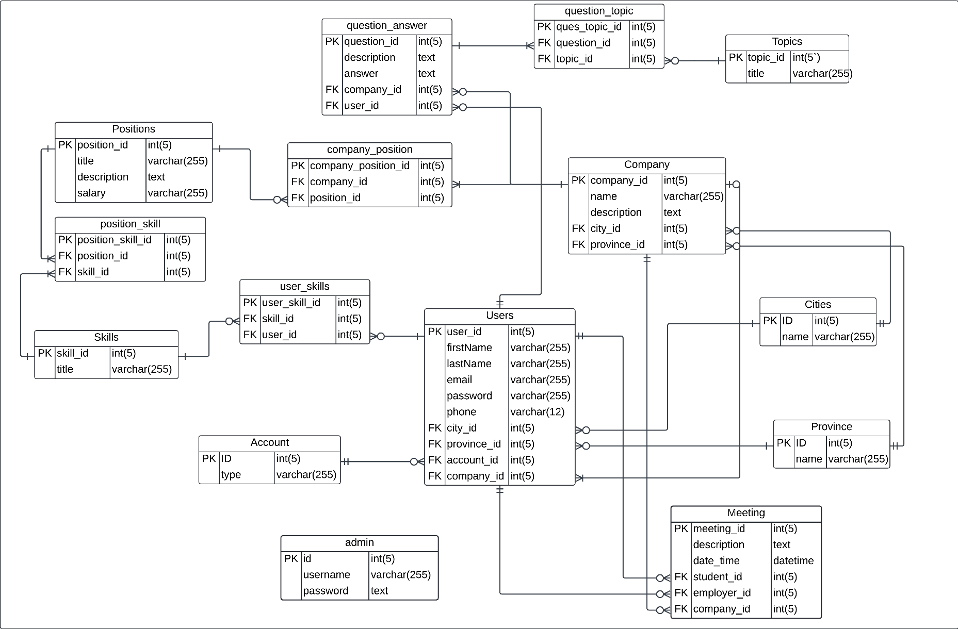

# **Content Plans**

# **Class Diagram**

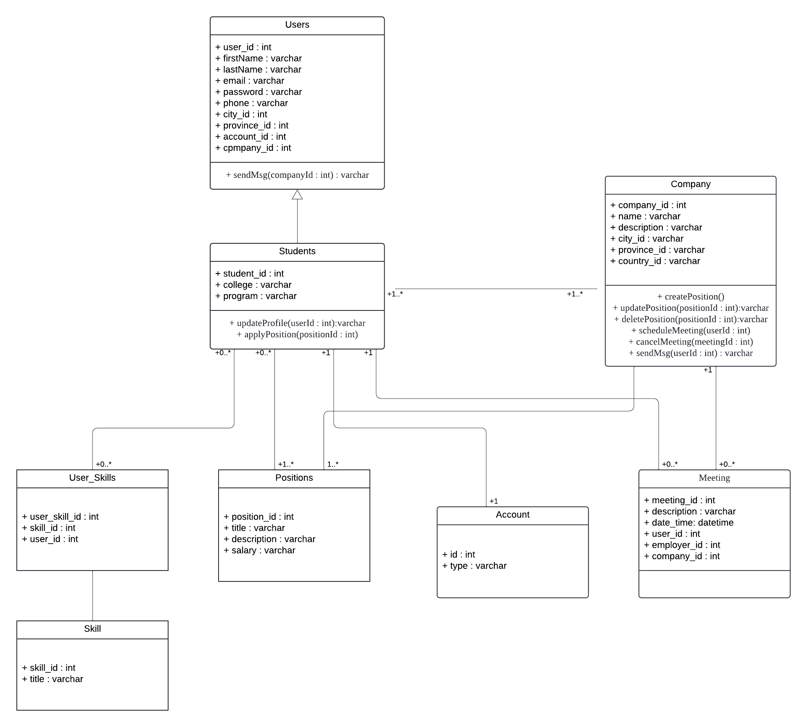

# **Prototype**

**Community Engagement (Forum):**

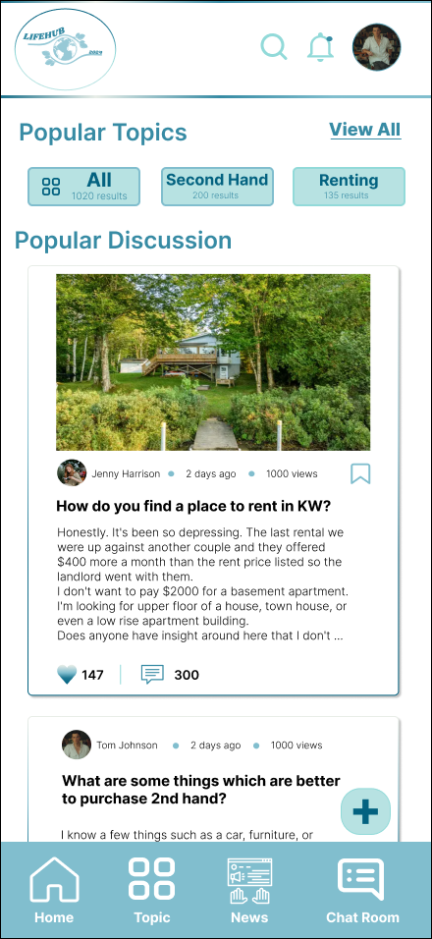 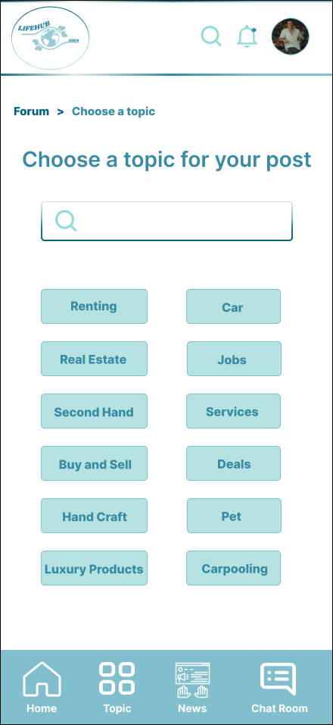

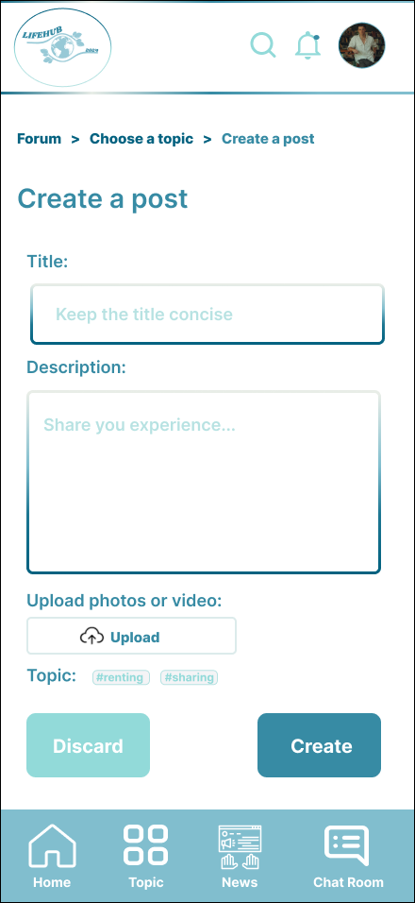 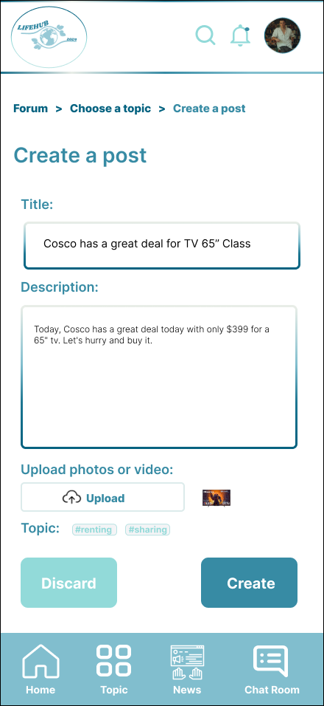

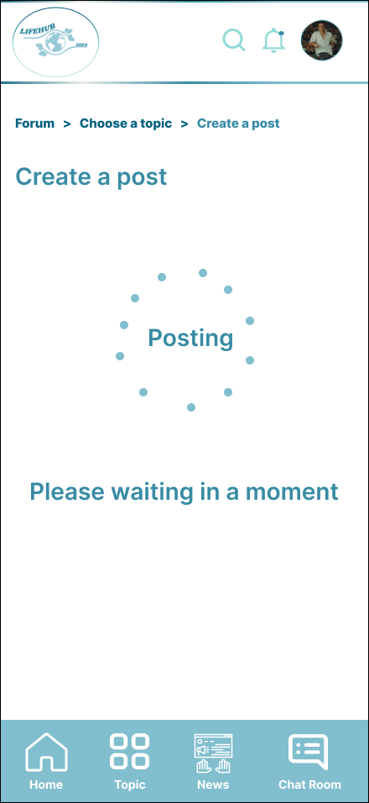 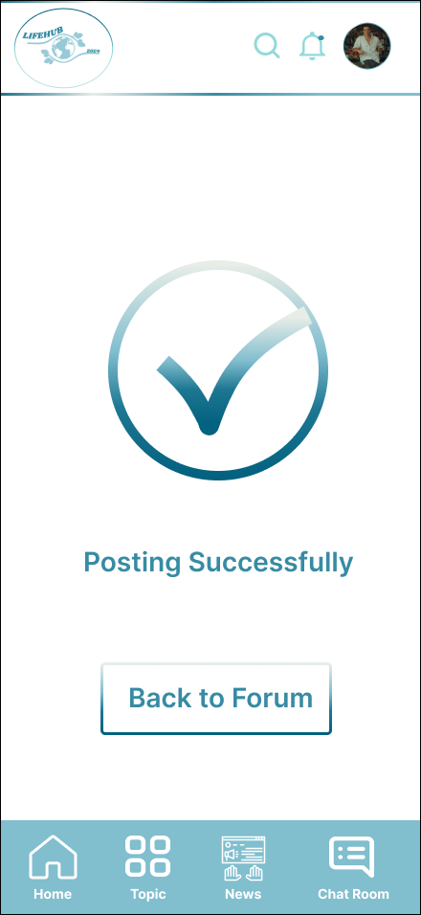

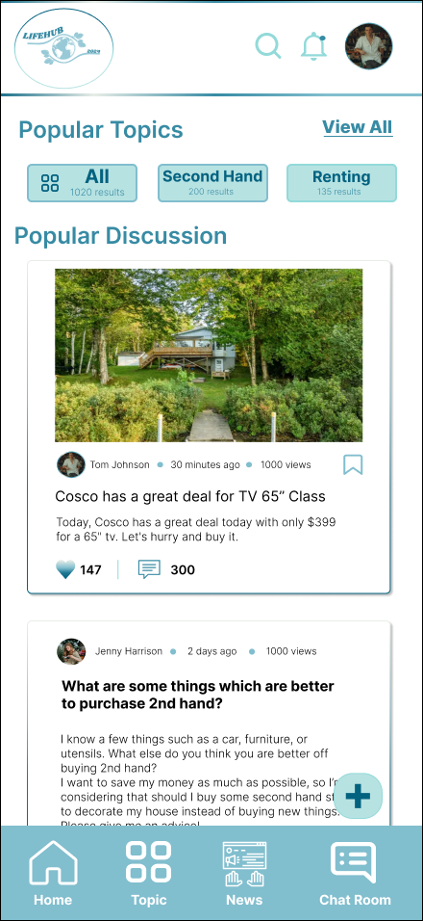

**Centralized Platform:**

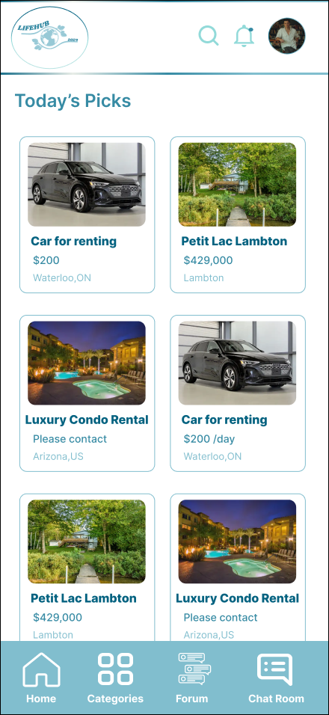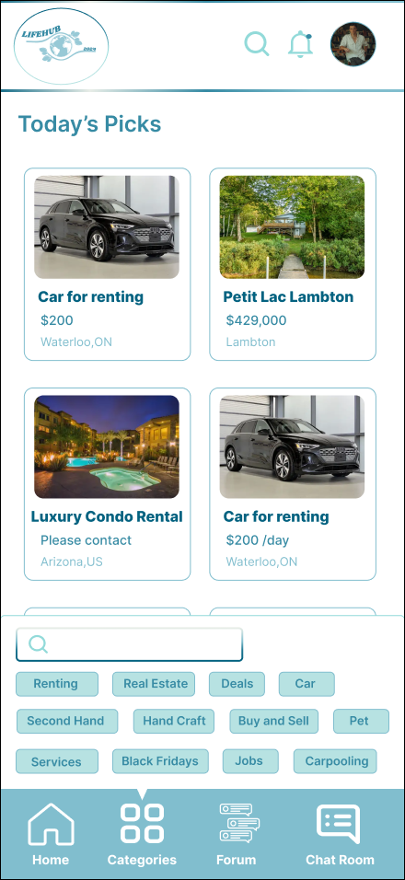

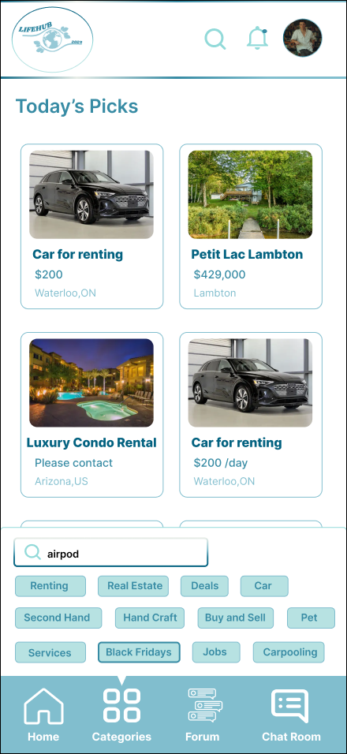

# **Agile Plan**

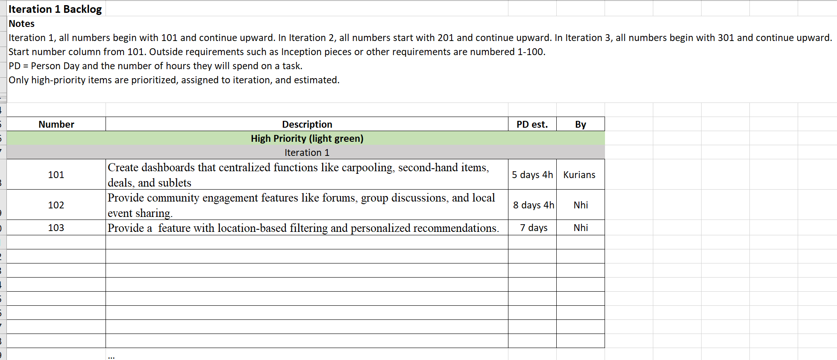

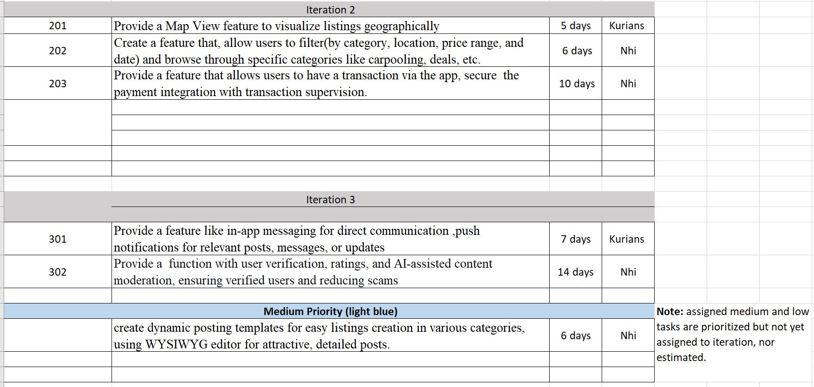



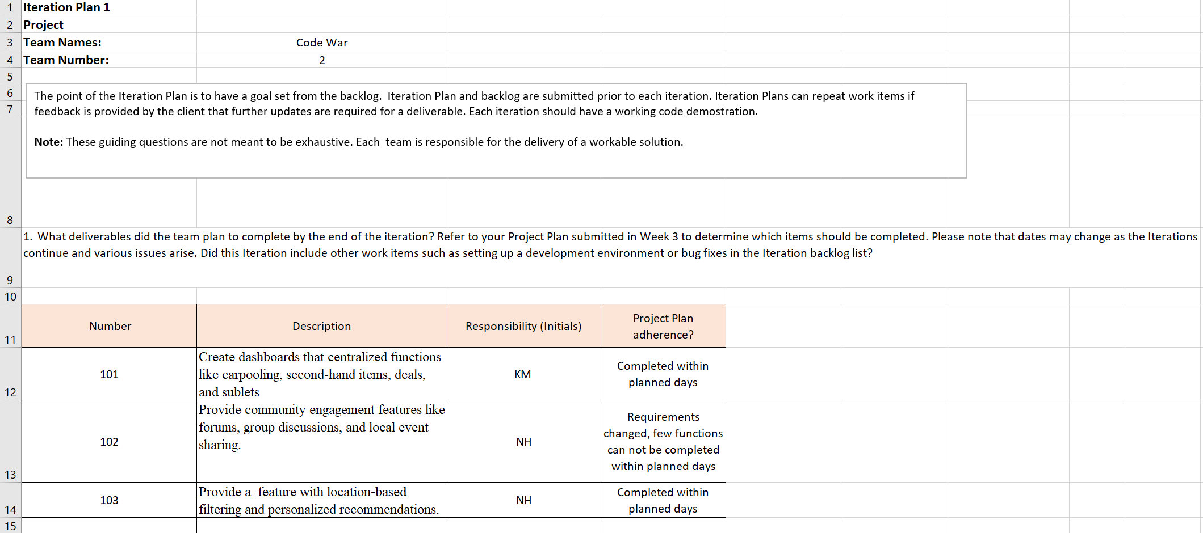

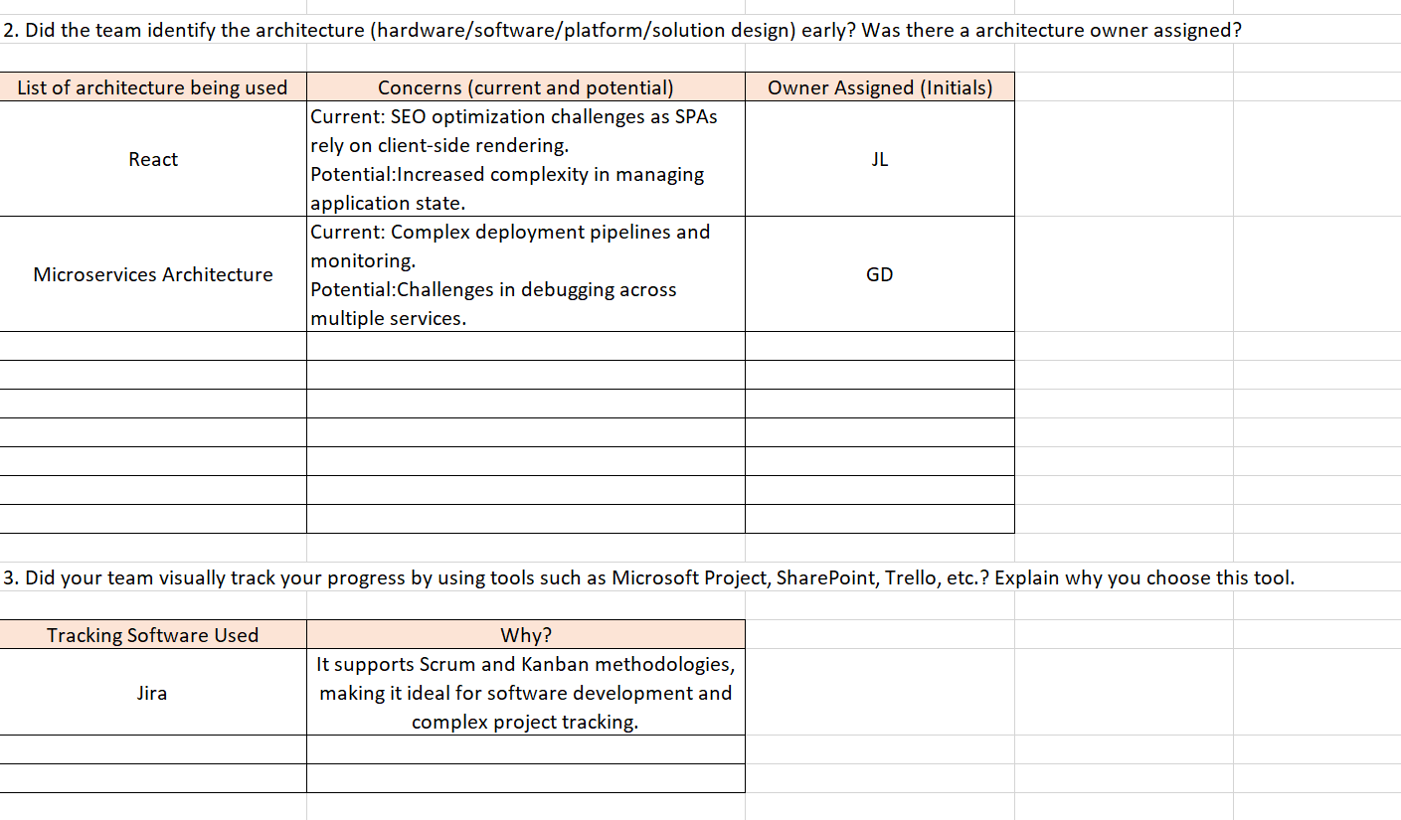

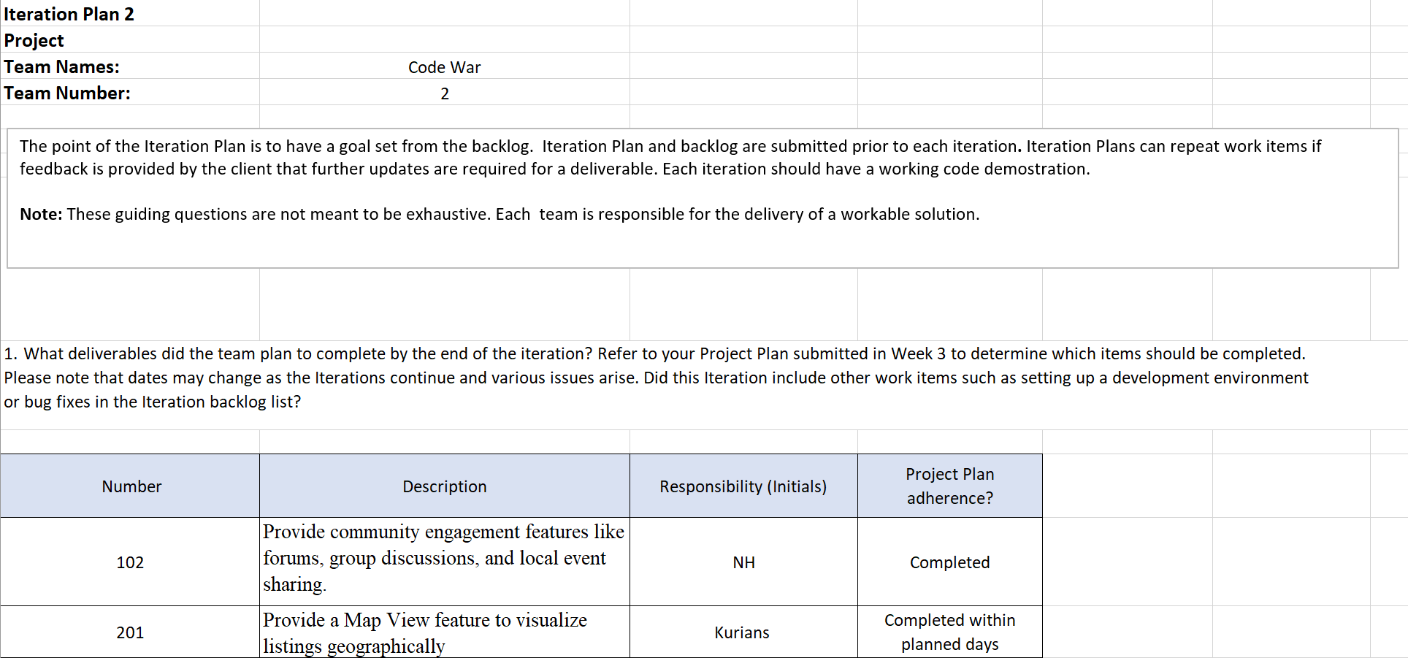

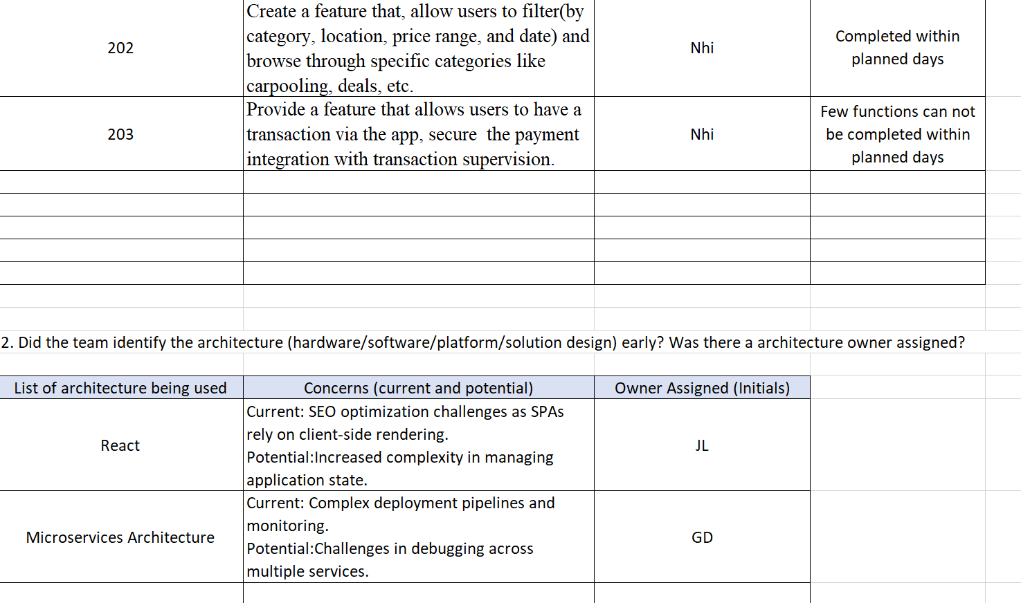

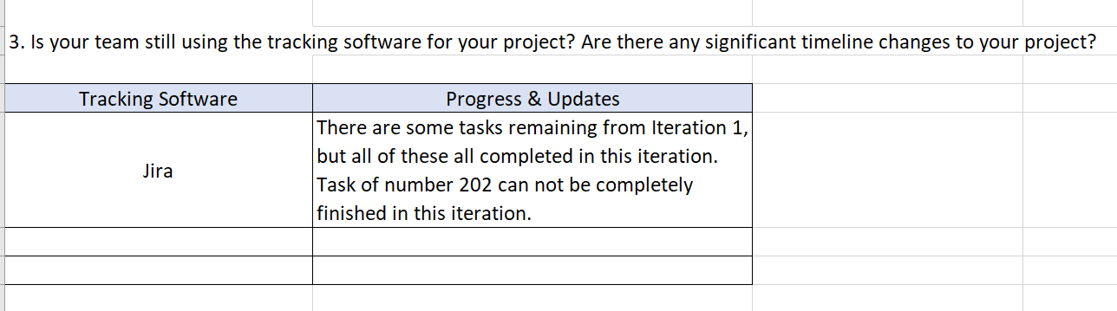

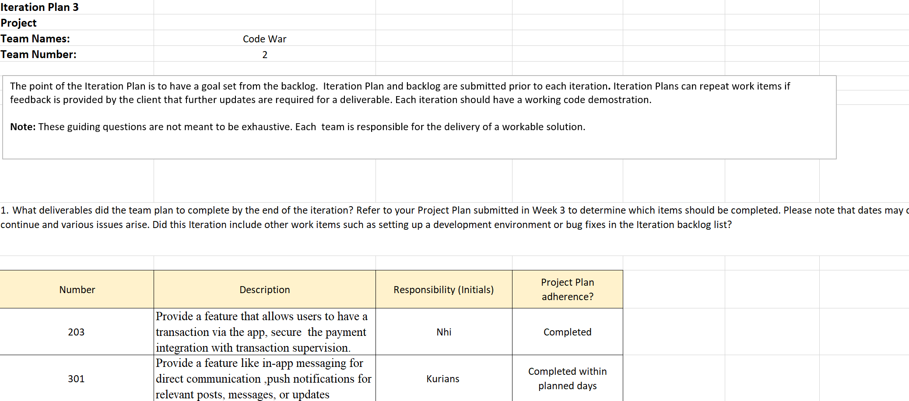

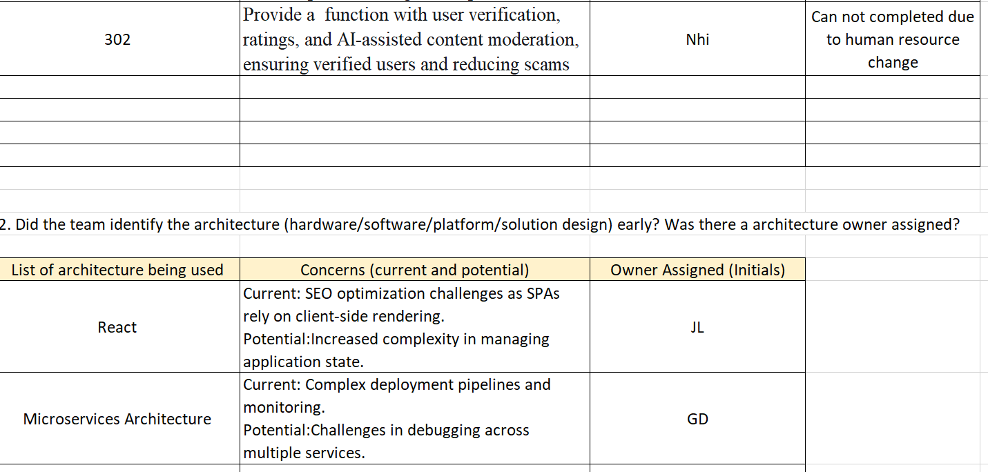

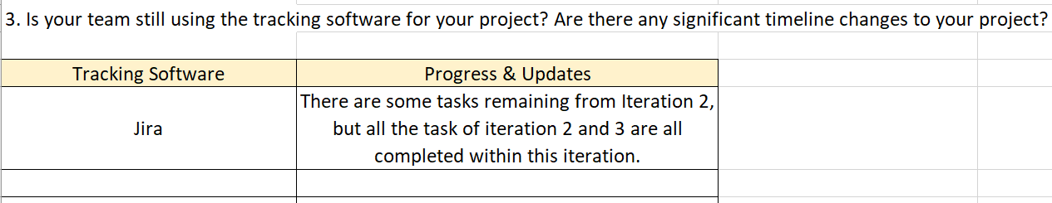

# **Conclusion**

To conclude, our unified platform is a big step toward making it easier for people to interact and take care of their daily requirements. This application gives customers a one-stop solution that saves them time and removes the headache of managing several platforms by merging carpool services, exchanging second-hand items, apartment sublets, and other community-based features. Its design places a strong emphasis on security, usability, and building trust so that users may interact with the platform with confidence and empowerment.

While community engagement tools like user profiles, ratings, and reviews guarantee transparency and promote deep connections among users, the integration of in-app payment systems with supervision further improves the security and dependability of every transaction. Our application aims to build a community where users may interact, exchange resources, and provide helpful support to one another in addition to providing services. We think this platform will become a vital resource for people looking for simplicity, convenience, and trust in their everyday interactions as we develop and enhance it further. This will allow them to save time and easily make better decisions. In addition to changing how individuals look for housing, offers, and carpooling opportunities, this software is reaffirming the value of community in the digital era.